**Central zoo**

User Guide

|  |  |  |
| --- | --- | --- |
| *Supervisor* | *Sir saim ahmed* | |
| *Batch* | *2202F1* | |
| *Group* | *A* | |
| *Serial No.* | *Enrollment Number* | *Student name* |
| *1* | *Student1367800* | *Areeba Rizwan* |

***USER GUIDE***

WELCOME(Index.html):

NAVBAR (home.html):



Home:

-The homepage is displaying the animals.You will find the modal here, slider and newsletter post. In the last you will find footer.

Slider (Index.html)

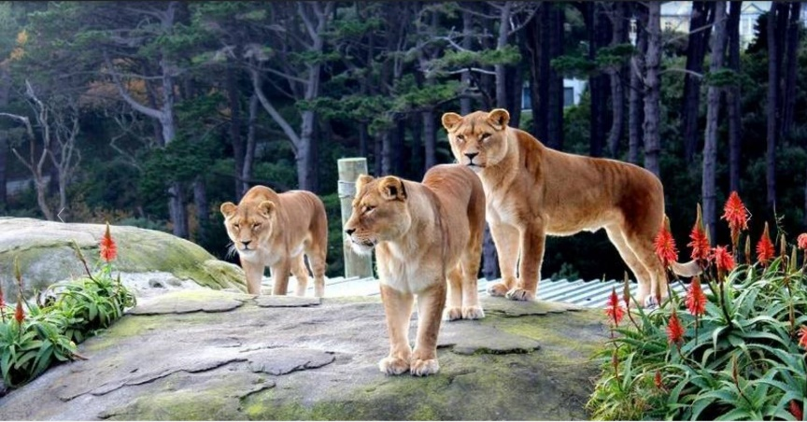





Galley (birds .html, animals.html, wateranimals. html):

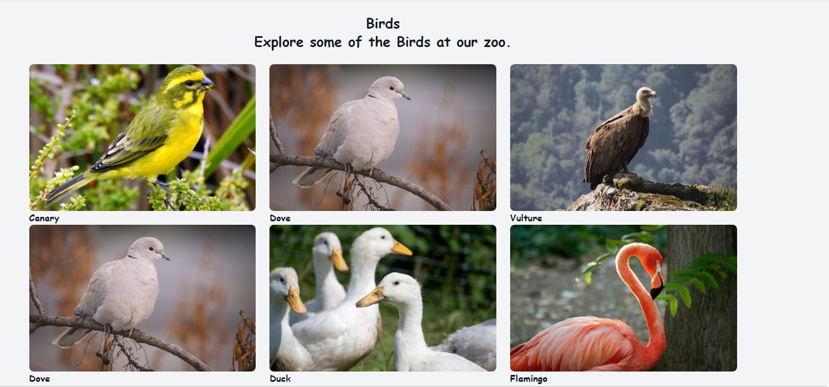

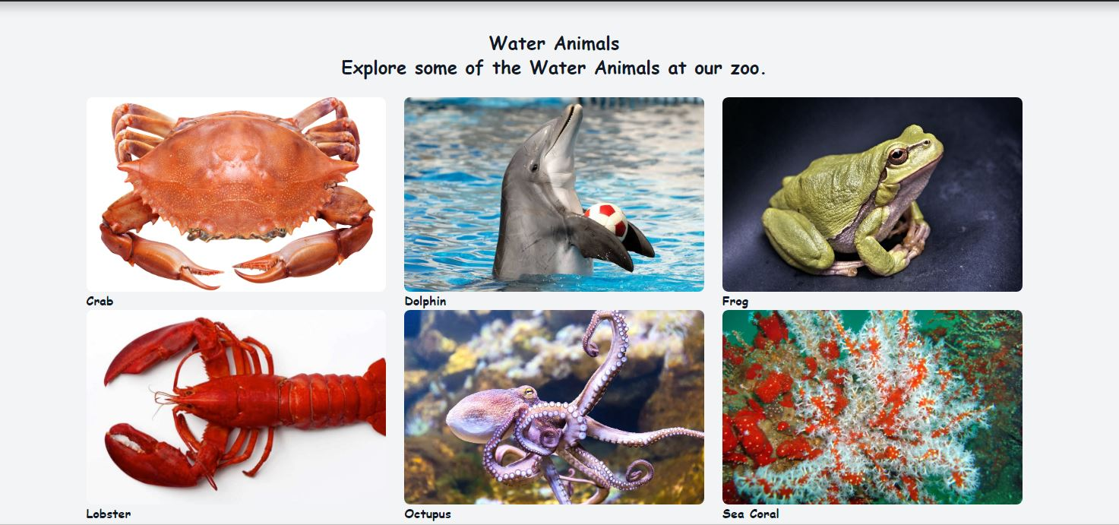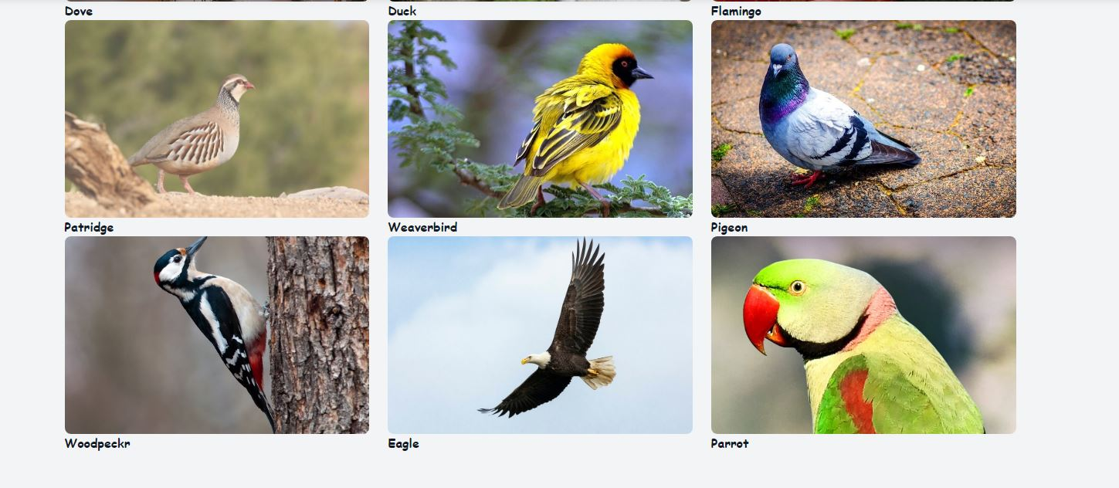 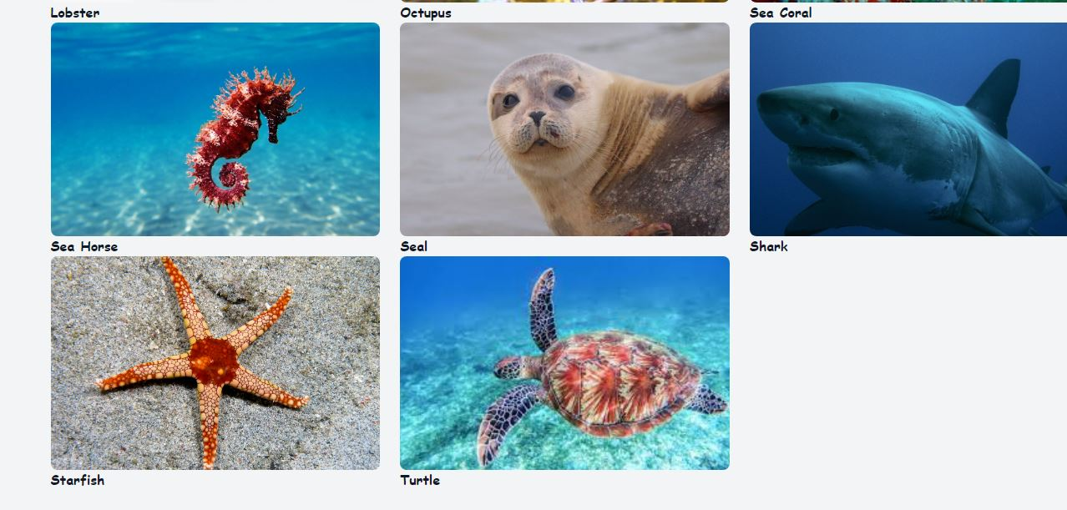

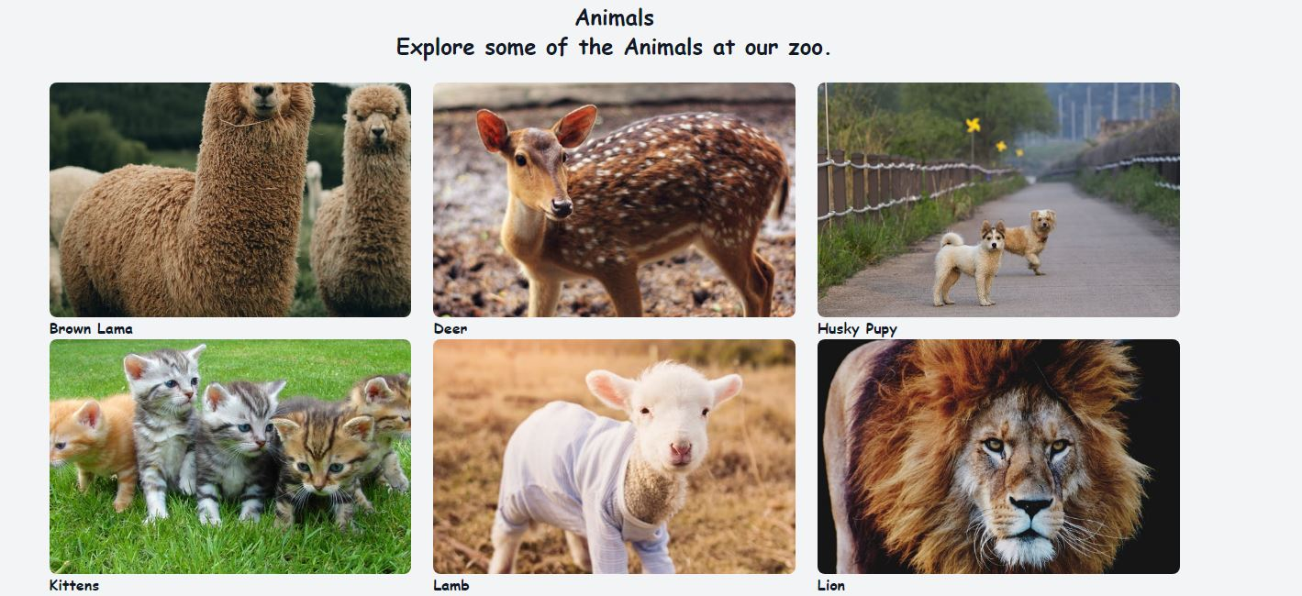

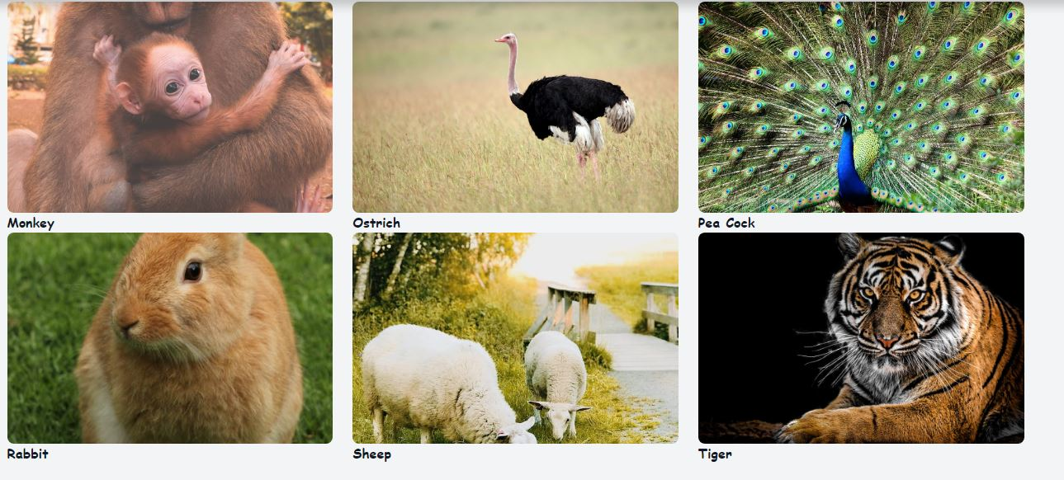

FOOTER (Index.html)



newsletter:

-Our newsletter subscription area.

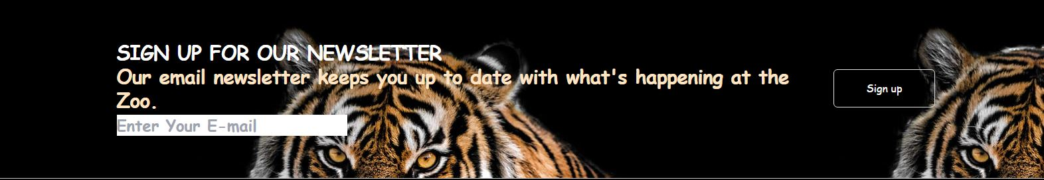

About:

-Our about page is describing about zoo.



Logo:

-when you click on logo it will redirect you to the top of that page of the website.



Contact us:

- User can contact us by calling at our number or goto feedback page to contact online and find us via map.

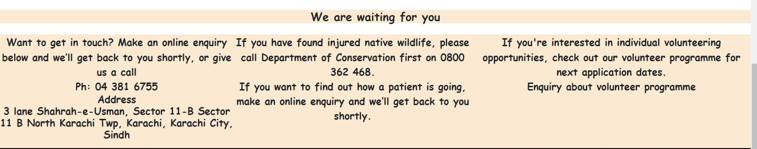

Store Locator:

-User can easily locate zoo.

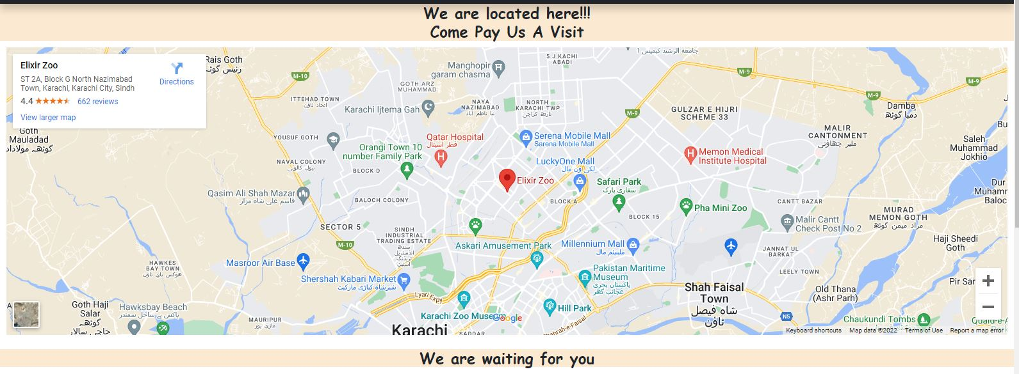

Feedback and Query page:

-give your feedback here



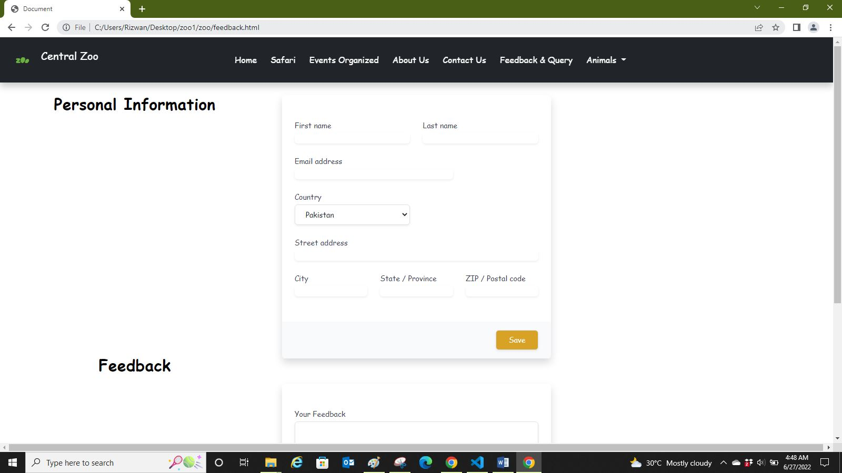

Safari Booking page:

-YOU CAN BOOK FOR SAFARI HERE.

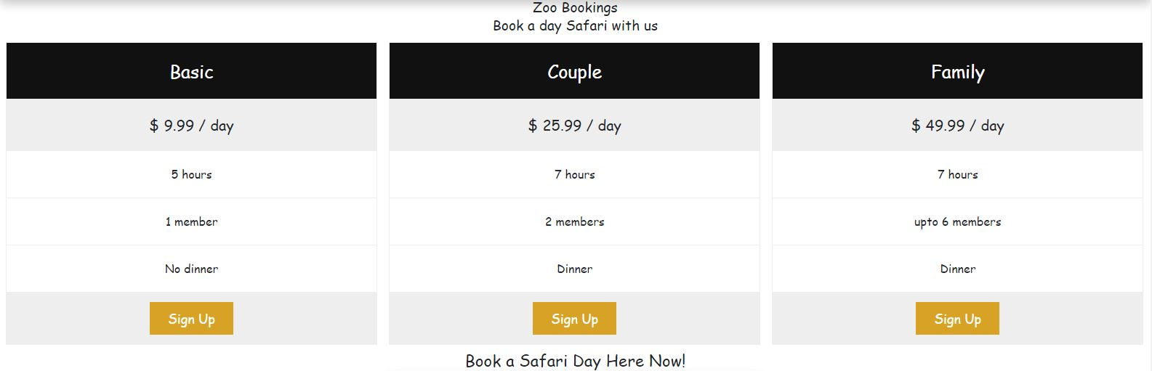

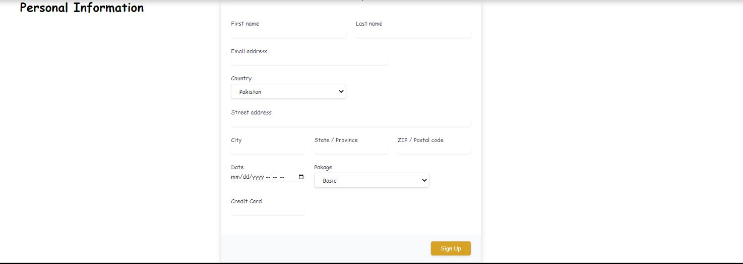

After filling out all this information it shows thank you alert

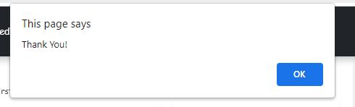

Events Organized Page is here:

